**ISDS 552**

**Project on**

**Car Dealership (Sales)**

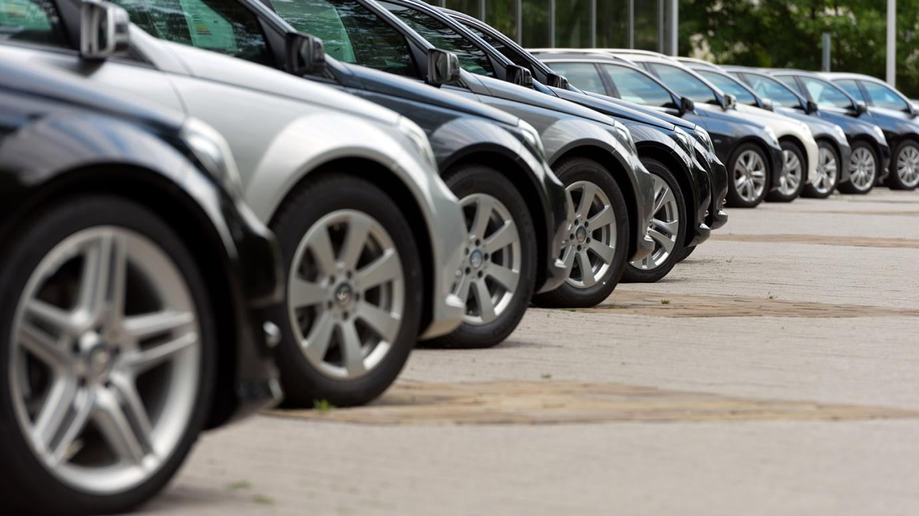

**By**

**Team- S3**

**Deepam Khirwar**

**Harshita Didwania**

**Kavindu Walimunige**

**Sanchit Singh**

**Sathiya Priya Jeevanandan**



**WND Diagram**

**Match Vehicles with Customer**

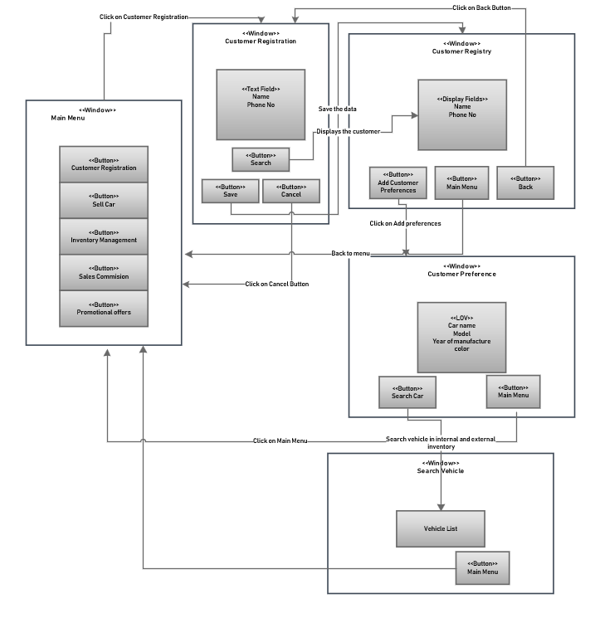

**GUI Diagram**

**Match Vehicles with Customer**

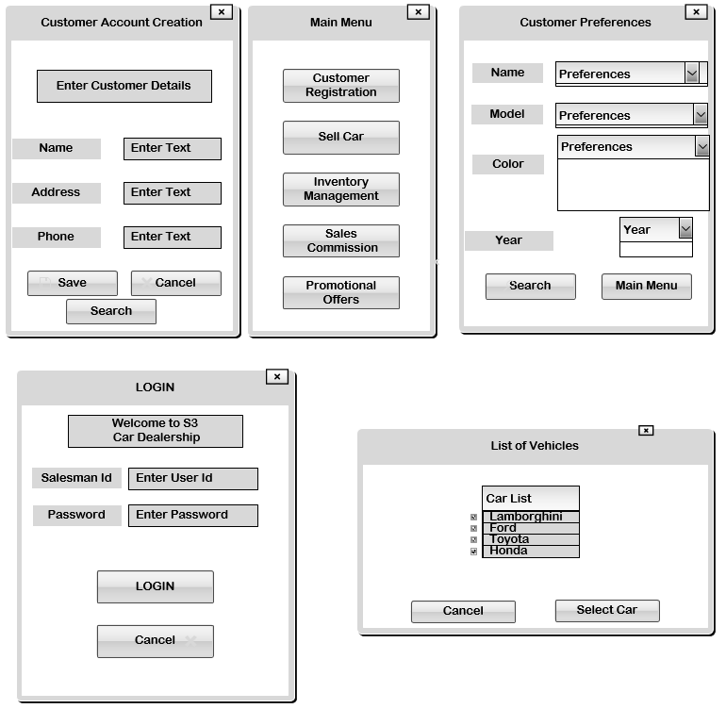

# **Sell Car**

## **WND**



**GUI  
Sell Car**

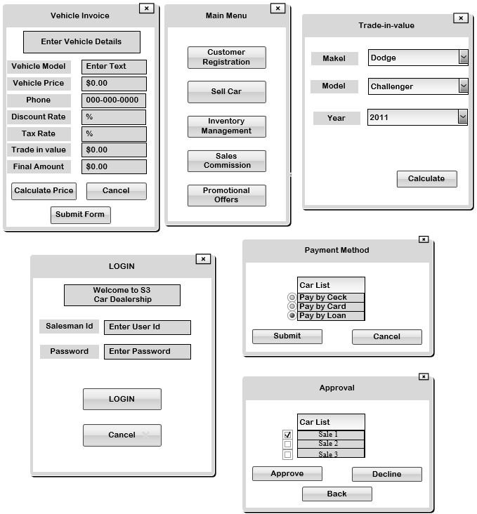

**Manage Inventory**

**WND**

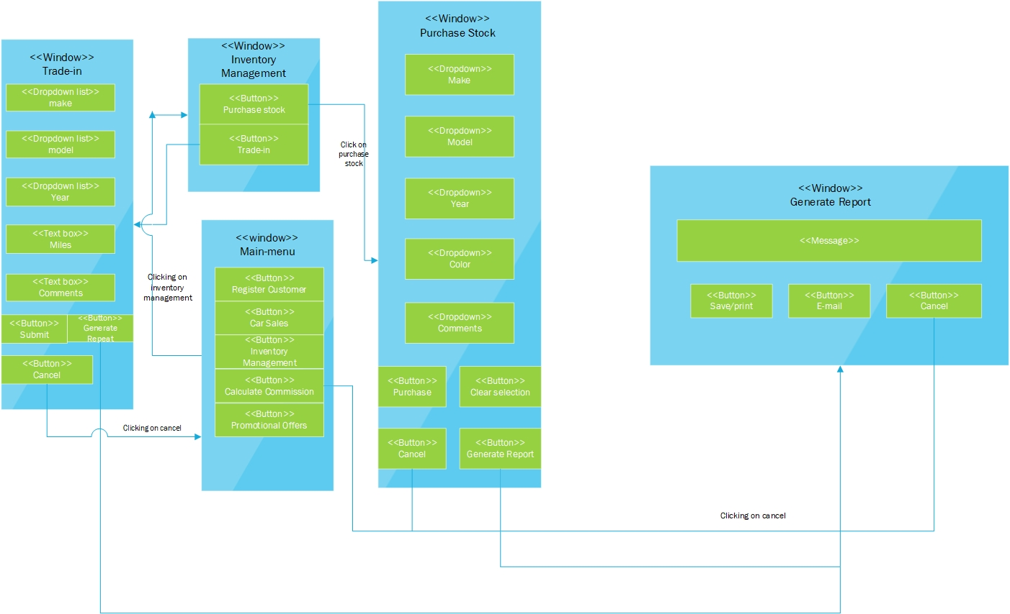

**Manage Inventory**

**GUI**

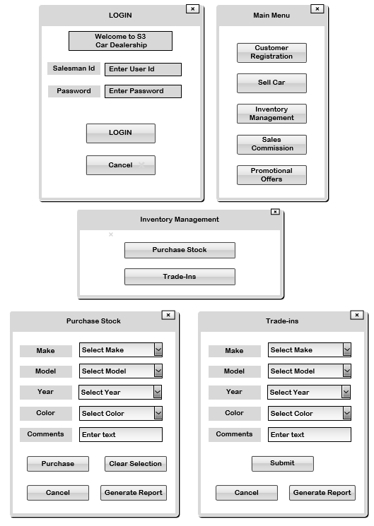

**Sales Commission**

**WND**

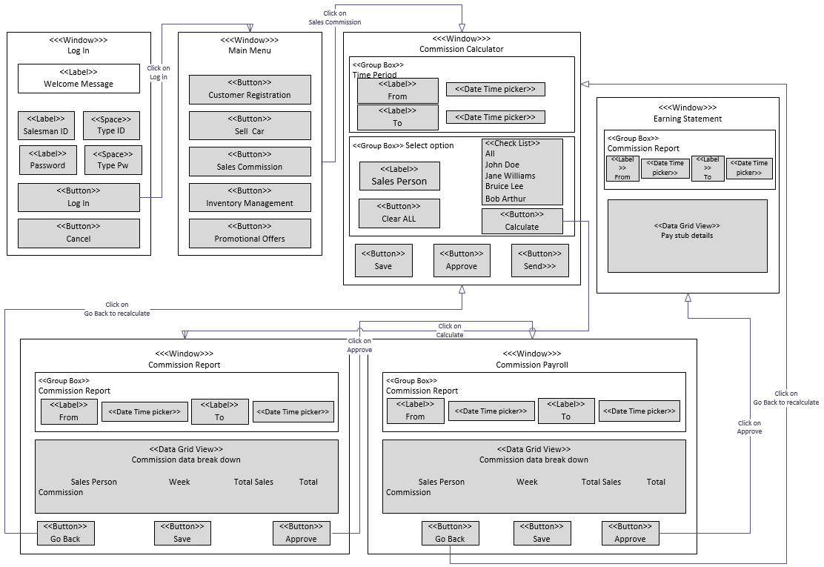

**Sales Commission**

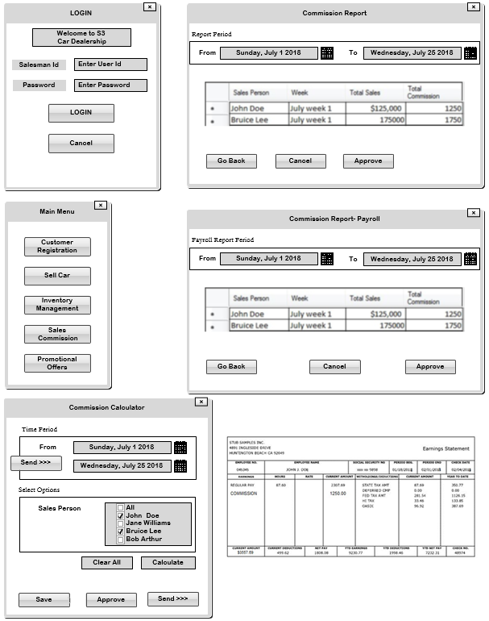**GUI**

**Identify Promotional offer**

**WND**

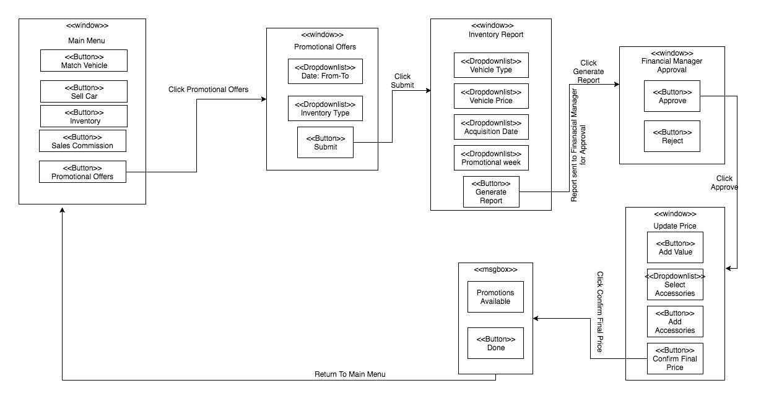

**Identify Promotional offer**

**GUI**

